Loading the database
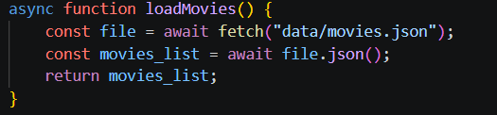

Preprocessing and Clustering
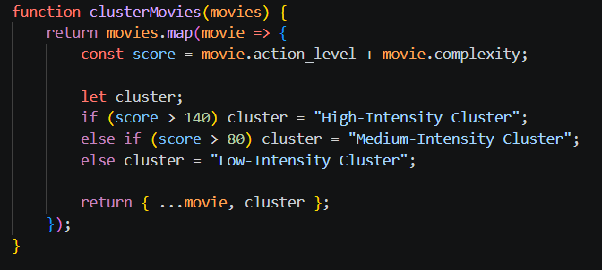

Prediction
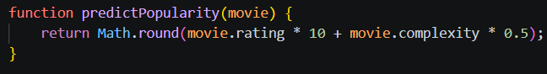

Filtering

Applying AI and Rendering Results
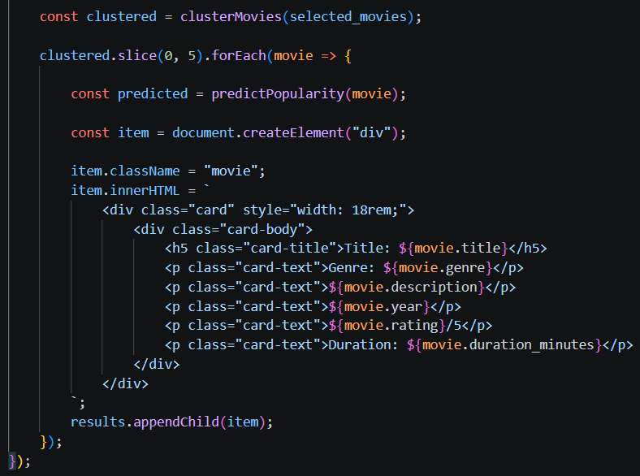

Example Input from the dataset
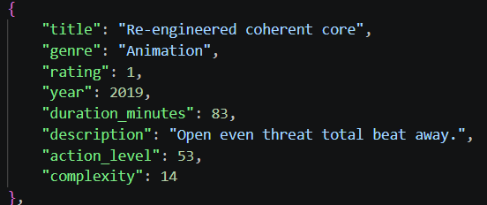

Example output from the user’s perspective


